Dear Parents / Carers
Year 4 Egyptians Visitor

As part of your child’s ongoing educational experience, Year 4 will be having an exciting visit from a historian on Wednesday 9th December. This is a fantastic opportunity in which a historian will be coming into school to talk to the children about Ancient Egypt, showing them many artefacts, weapons, and the mummification process.
The children will have the opportunity to be active participants throughout the day by participating in a carousel of activities including Ancient Egyptian games and dances, drama activities, writing hieroglyphics and gain valuable knowledge from the delivery of the workshop. Children have thoroughly enjoyed the day in previous years, and we hope it will be a success this year too.
This workshop is an engaging way to support the learning we will be doing in the classroom about the Ancient Egyptians in this part of the Autumn term. This visit will take place in school.
For this day to be as stimulating as it can be, we are asking the children to dress up as Egyptians. The costume could include bed sheets, paper, toilet roll, white t-shirts etc. We have attached some ideas for the children to be able make their own costumes using items found at home and children can be as creative as they would like.
We are requesting a voluntary contribution of £4.35 per child to cover the cost of the workshop; if voluntary contributions do not meet the cost of the visit, then it may be cancelled. Payment can be made online through the My Child at School app. We will not exclude any pupils from taking part in the workshop because their parents cannot afford to contribute at a particular time. If this is the case, please make an appointment to speak with Mrs. McGibney. Unfortunately, we are unable to offer refunds if your child is off poorly and unable to take part on the day. (Cost of workshop: £378.80 divided by 87 children = £4.35 per child).
Please complete the permission slip below and return to school by Friday 20th November.
Yours sincerely
Year 4 Class Teachers
Mrs. Bassi(Year Lead), Miss Heath & Ms Malik ________________________________________________________________________________________
I give / do not give permission for (child’s name) _____________ in class ______ to take part in the Egyptian workshop on Wednesday 9th December 2026.
I have paid via the My Child at School app a voluntary contribution of £4.35.
Signed: ___________________ (parent/guardian) Date: ______________
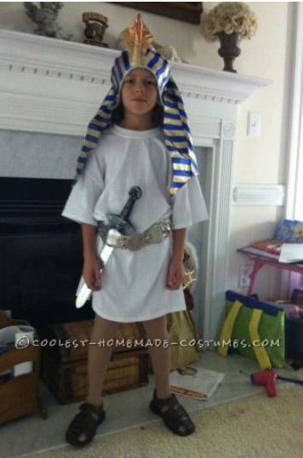
Homemade costume ideas
